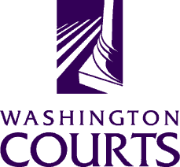

June 19, 2018

TO: Judges, Commissioners, County Clerks, Court Administrators, Libraries, Attorneys, and Public

FROM: Merrie Gough, AOC Sr. Legal Analyst

SUBJECT: June 2018 Summary of Changes to Surrender of Weapons forms

The Washington Pattern Forms Committee updated the Surrender of Weapons forms to implement recommended changes and:

- Laws of 2018, ch. 226 (EHB 2519) Concealed Pistol License Release

Detailed descriptions of the changes to the Surrender of Weapons forms are in the table below:

Form number | Form title and description
WPF All Cases 02-090 | Order to Release Weapons  In the left-hand side of the caption, change the lines for the Respondent and Defendant as follows:  Respondent (DOB)  Defendant (DOB)  On page two, in the box below the signature line, below the heading “Obtaining your firearms,” and after section “2” beginning with “Firearms will only…” insert the following new heading and text:  “Obtaining your concealed pistol license  Your concealed pistol license will not be returned to you until the law enforcement agency determines you are eligible to possess a firearm under state and federal law and you meet the other requirements to be eligible for a concealed pistol license under RCW 9.41.070.”  Remove “3” before the last line and line up “See” with the headings.

